INSTRUCTIONS FOR USING THE "ECO INPUTS" APPLICATION

Developer: Peter Bernad
Contact: peter.bernad@um.si (any suggestions or bug reports are welcome)
Current application version: a1.9.3
Link to the application: https://eko-inputi.fkbv.um.si/

Registration:
When you click on the word "Registration", a new window appears where you enter basic information. If you don't have some information, you can enter a slash "/" in the field.
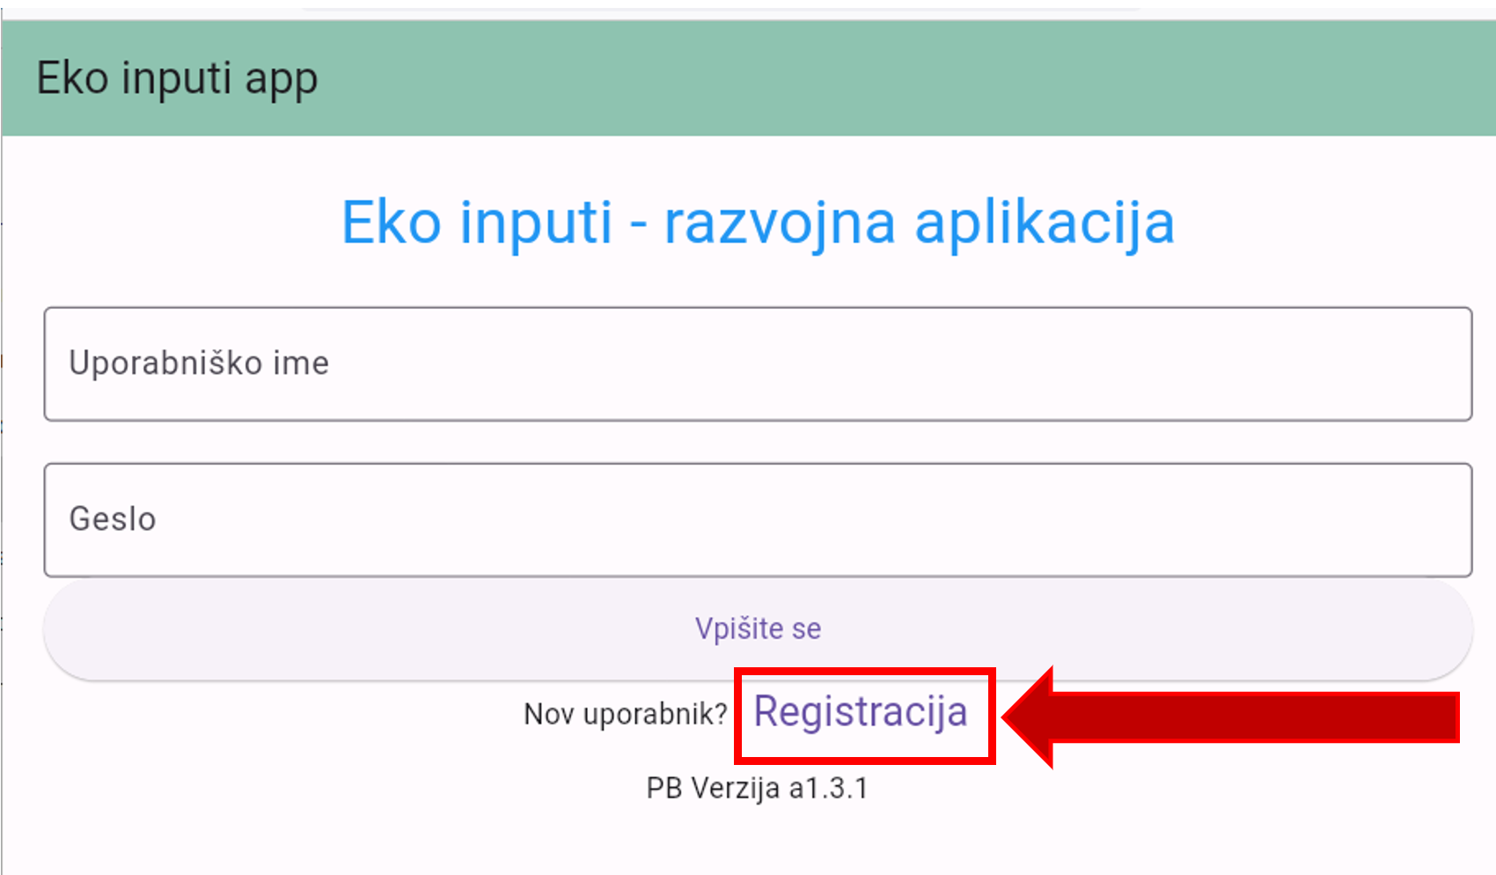

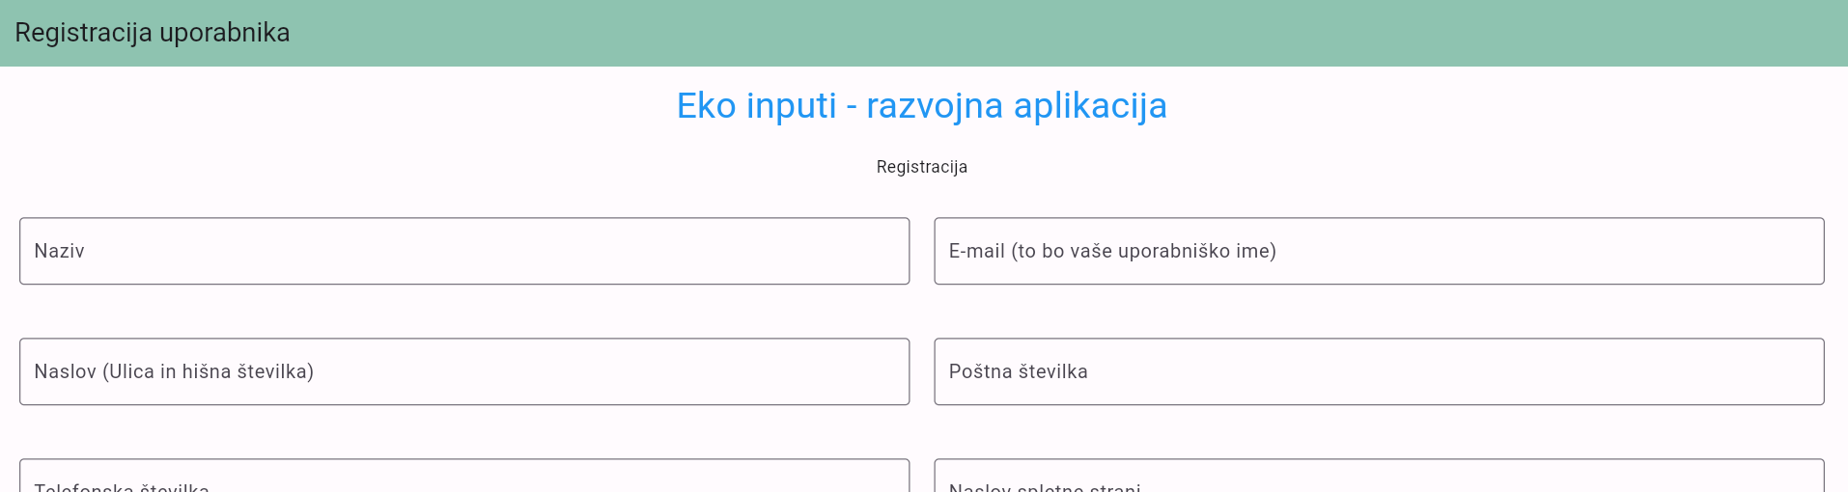
After entering, click on the "Register" button, which is at the bottom of the website. If everything has been completed, the application will return you to the original page and the registration is done.
TIP: When setting a password, we recommend at least 8 characters, at least one capitalization, at least one number, and a special character (e.g., "!" or "#").
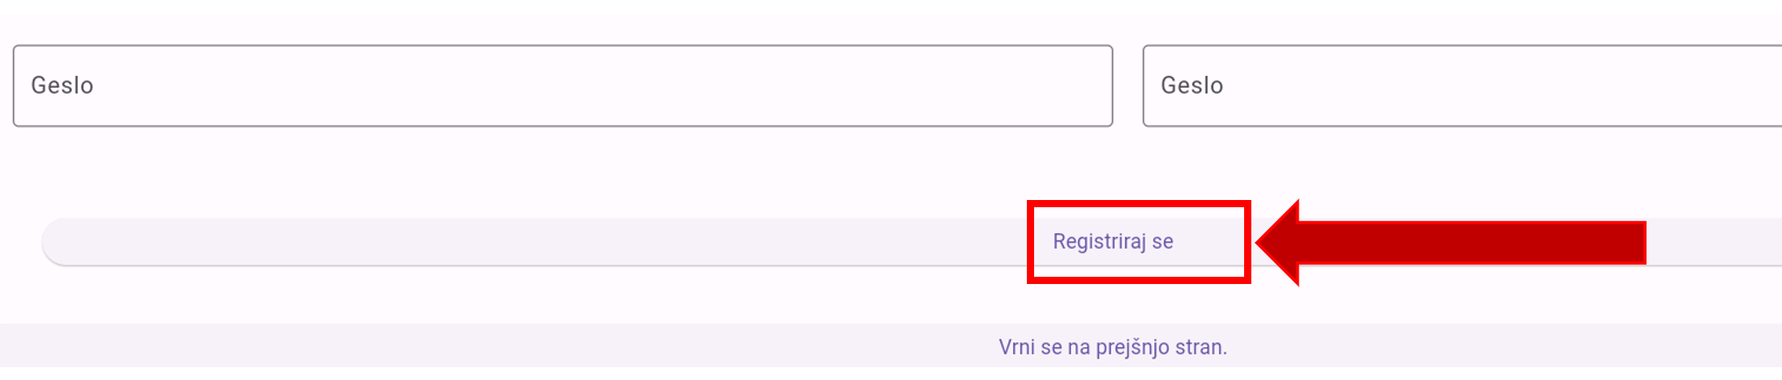

After successful registration, it is necessary to contact peter.bernad@um.si. Only then can your user account be confirmed (automatic notification via e-mail will be arranged in future versions).

Once you receive a confirmation email from your administrators, you can successfully sign in to the app.

SIGN IN TO THE APP
(If you have forgotten your username or password, please contact us at the email addresses above).
When you log in, you enter your username (the e-mail address you entered during registration) and password. Then click on the "Sign In" button.
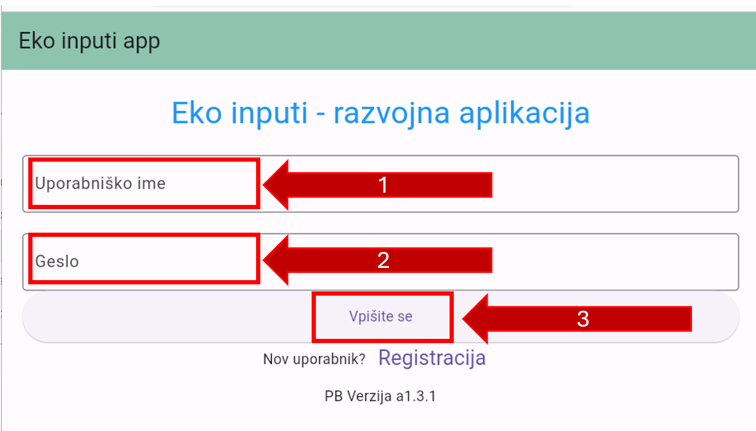

Upon correct entry, a new window will appear, where in the future a list of entered resources will be displayed:

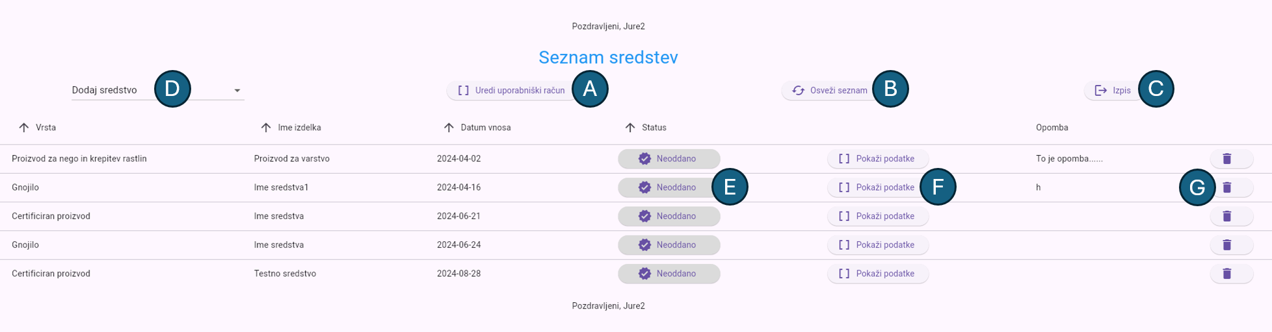
A – Display of user data. You can update/add company information here.
B – If the list won't update after submission/deletion, you can manually refresh it here.
C – Opt out of the programme. The app will take you back to the sign-in page.
D - Add a new asset. A drop-down list appears here where you select the appropriate type of asset you want to add. "Other" includes assets of the following categories: organic seeds, organic seedlings and propagating material, animal care and treatment, beekeeping, feed and processing additives.
E – Button to submit the asset for review. If the button is no longer orange, the reviewers review the entered data and provide feedback. Statuses now have new messages and are color-coded:
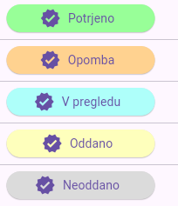
When the status is "Under review" or "Confirmed", the asset can't be edited. Editing is re-enabled when the reviewer makes a note or when the reviewer releases the status by agreement.
F – Editing, adding data/relevant evidence to the application.
G – Deletion of the asset.

ADD AN ASSET TO YOUR APP
To add a new asset, click the "Add New" button. This also applies if you already have a certificate of eligibility for any of these categories, adding them to this list. You will see the following drop-down list:
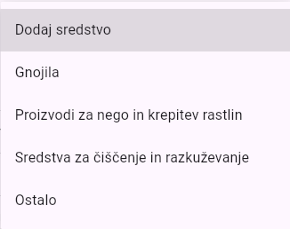
As we have already described on the previous page of the legend, "Other" includes assets of the following categories: organic seeds, organic seedlings and propagating material, animal care and treatment, beekeeping, feed and processing additives.

Click on the desired type and enter the appropriate data:
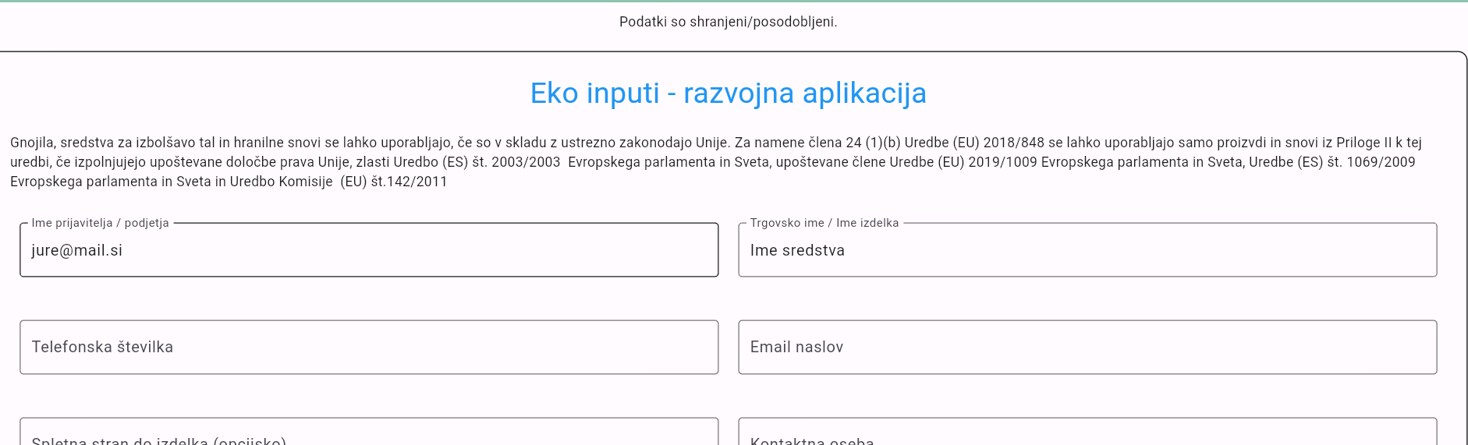
There are always basic fields at the beginning that you can fill in if they differ from your account information.

Below the basic data fields on the left, there is a list of categories, where you can specify the type of assessment by clicking: 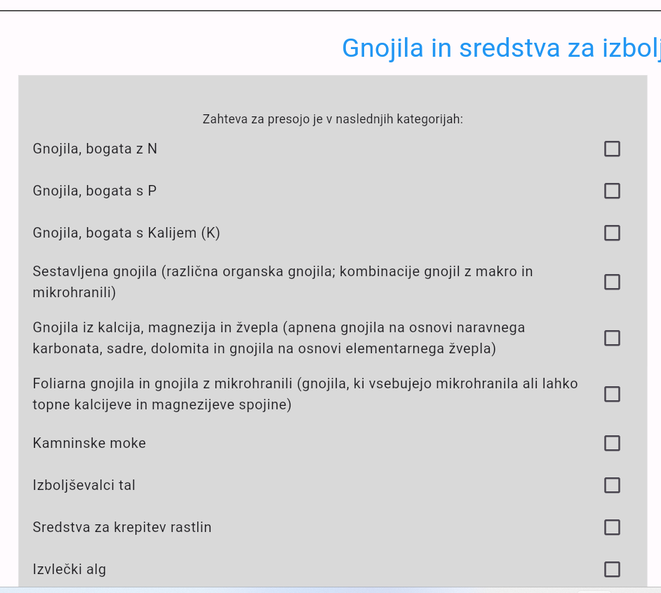
The right column shows additional fields to fill in:
(The contents of the fields and categories are different from the type of asset you want to add)
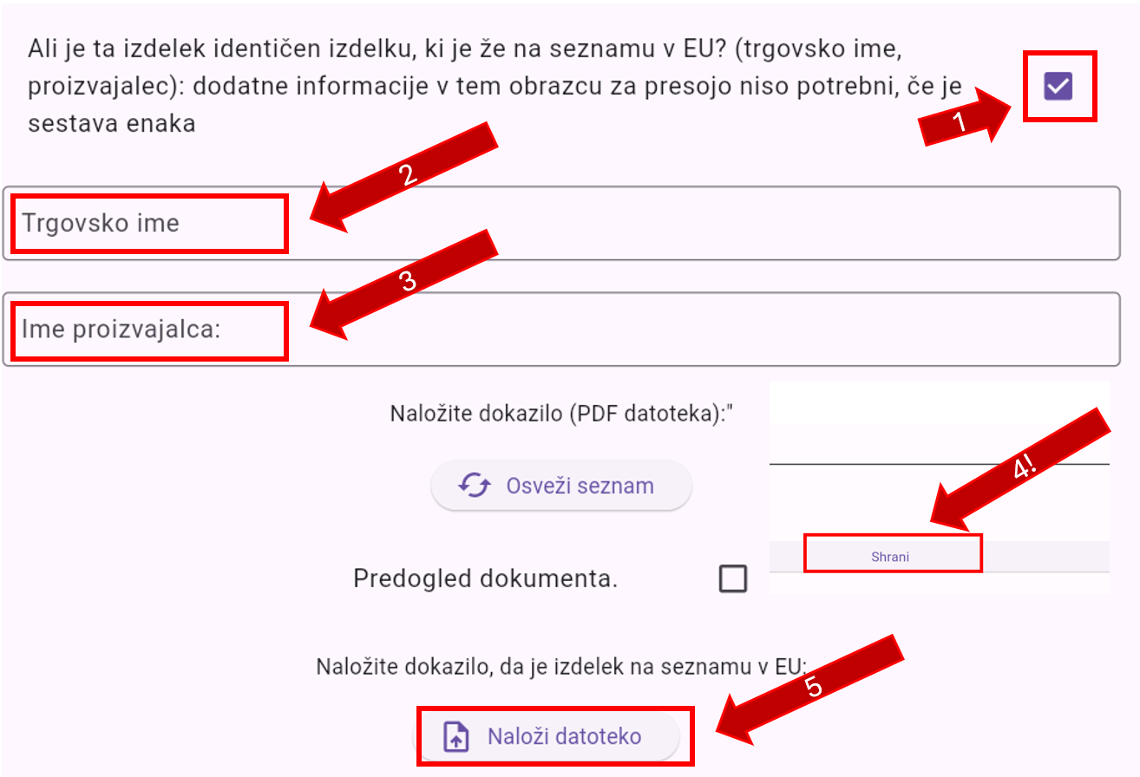
If your product is identical to a product already listed in the EU, tick this in the checkbox circled in the image above. You then enter the relevant information in the fields that appear and upload the proof.
IMPORTANT: Before uploading the proof, click on the "Save" button (at the bottom or top of the tab). The plot is currently still in the process of being resolved and will be fixed with the next version.
You enter the nutrients manually by filling in the fields as shown below. (e.g. for 12% potassium is entered in the first field K, and in the second 12 and clicks on the "Add nutrient" button.
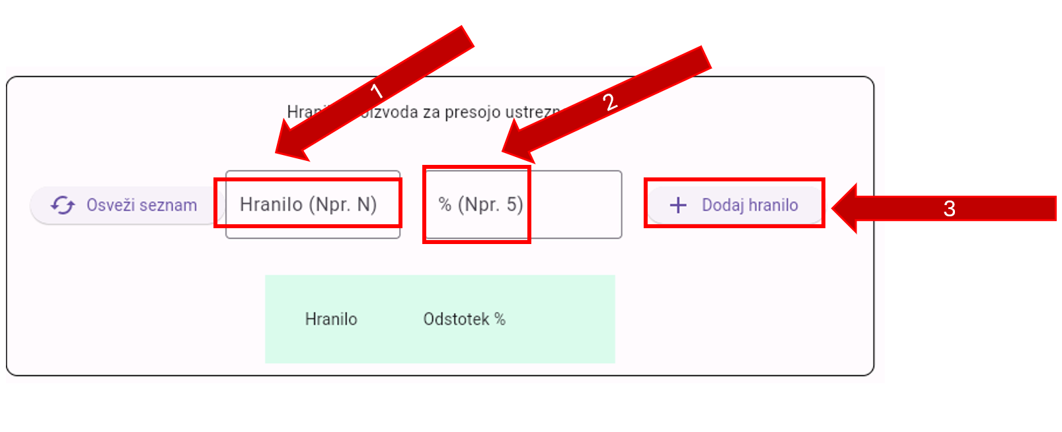
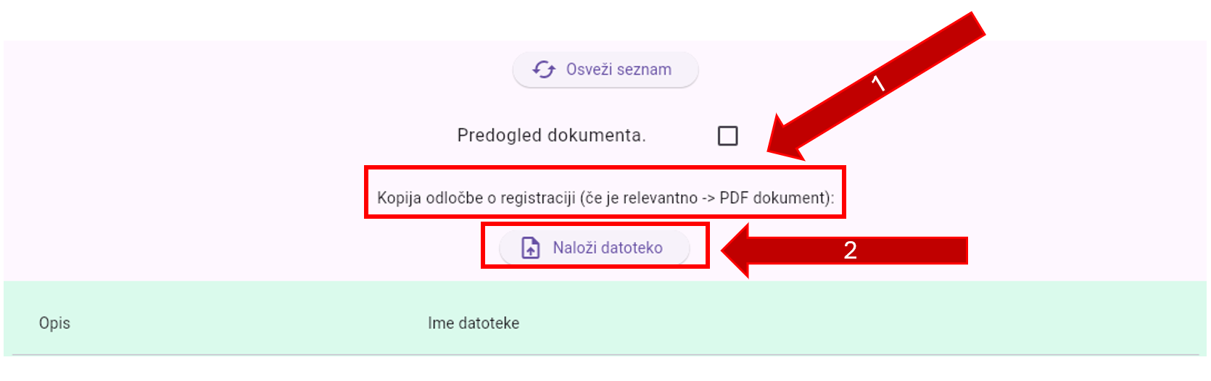
When uploading files, it is necessary to find the appropriate table according to the type of document. Only ».pdf format files are allowed to be uploaded." If you already have a certificate of eligibility, create a new asset and upload the certificate there under the lowest section (Other documents, etc.).
Fill in the other possible tables in a similar way to the table for chemicals. If a list is not updated immediately, it is necessary to press the appropriate "Refresh" button or wait a second. During the updates, the application will be optimized as much as possible.

IMPORTANT: At the bottom of the page, you need to click on the "Save" button. The table of nutrients, files, and components is saved automatically, but the other fields are not.
