Privacy Policy

This is the privacy policy ("Privacy Policy") of Morus App, and describes how Morus App handles Personal Information (as defined below) that users ("You," "Your” or "User") provide to Us or that We collect from You through the use of Our Morus App, which is located at https://dsr.feri.um.si).
The recipients of the data that you provide to Us are the Data Controller and the categories of people indicated below:
- CREA (Consiglio per la Ricerca in agricoltura e l’analisi dell’Economia Agraria, con sede principale in via della Navicella 2/4, ROMA - ITALY), data controler,
- University of Maribor-UM and CREA, head Morus censing organizations
- affiliated organizations participating in Morus censing as national administrators as defined at the “List of Morus App administrator board” hyperlink),

ARACNE partners involved as Morus APP administrator board

Partner role in . | Participant organisation name | Short name
Coordinator, data controler, super-administrator | Consiglio per la Ricerca in  Agricoltura e l'Analisi dell'Economia Agraria | CREA
Super-administrator, head Morus cenzing organization | Univerza v Mariboru | UM
national administrator | Nauchen Tsentar Po Bubarstvo  Vratsa | SCS
national administrator | Ethniko Kai Kapodistriako  Panepistimio Athinon | NKUA
national administrator | Instituto Murciano de Investigacion y Desarrollo Agrario y Medioambiental (IMIDA) | IMIDA
national administrator | Chemins De La Soie - Des Cevennes aux Alpujarras | ASSOIE

For levels of published data access in the system see Figure 1.

Purpose and legal basis of the processing

Purpose of the processing | Legal basis (art. 6 GDPR)
The personal data collected are aimed at collecting information for the realization of the ARACNE scientific project. | a) The interested party has given his consent to the processing of his personal data for one or more specific purposes.
Purpose of the processing | Legal basis (art. 9 GDPR)
The personal data collected are aimed at collecting information for the realization of the ARACNE scientific project. | a) The interested party has given his explicit consent to the processing of such personal data for one or more specific purposes, except in cases where the law of the E. Union or of the Member States states that the interested party cannot revoke the prohibition referred to in paragraph 1 of article 9 GDPR.

We inform you that you qualify as an “interested party” pursuant to art.14 of the Regulation (EU) 2016/679 (General Data Protection Regulation) in relation to the personal data of which CREA (Consiglio per la Ricerca in agricoltura e l’analisi dell’Economia Agraria, headquarters in via della Navicella 2/4, ROMA - ITALY) comes into possession as Data Controller in the context of the ARACNE Project’s activities. The aim of the Project is to recreate a cultural, scientific, technological and touristic route on the trail of the European Silk Road, with the participation of institutional and private partners throughout Europe.
This Privacy Policy is subject to Our Terms of Use at https://www.fkbv.um.si/?page_id=15936&lang=en. We may update this Privacy Policy from time to time, as specified in the “Privacy Policy Changes” section below.

Your Consent
You should read the entire Privacy Policy carefully before submitting information to Us or using Our Platform. Whenever You submit personal and non-personal information via Our Platform or otherwise to Us, whether online or offline, You consent to the data collection, use disclosure, transfer, and storage of that information in accordance with this Privacy Policy under the Art. 6 of the GDPR.

Types of Information We Collect
"Personal Information" means information such as Your first/middle initial or name, last name, e-mail address, mailing address if different, state, telephone number (optional), and any other information that could allow someone to identify You or contact You, including information collected through session cookies and other technology.
Morus App collects Personal Information of the sort that web browsers, hardware, software and servers typically make available, browser type, language preference, referring site, pages viewed, one or more cookies that may uniquely identify your browser, and the date and time of each visitor request. Morus App purpose in collecting this information is to better understand how Morus App visitors use this Platform. From time to time, researchers administering the Morus App may release such information in the aggregate, e.g., by publishing a report on trends in the usage of the Platform.

How We Collect Personal Information
Morus App may collect Personal Information when You choose to interact with Morus App in ways that require Morus App to gather such information, such as if You browse on Morus App, register as an Morus App User, update or add information to Your Morus App profile, provide content to Morus App through Your computer or phone, or otherwise communicate or engage with Us about the Morus App Services. When You record an encounter with an individual tree at a particular time and location and post the concerning information or pictures on Morus APP (an “Observation”), We may collect Your User ID, latitude and longitude of the site of the Observation, the place name of the site of the Observation, the date and time of the Observation, the metadata associated with image and the time zone of the site of the Observation. The amount and type of information that Morus App gathers depends on the nature of the interaction. In each case, Morus App collects such information only insofar as is necessary or appropriate to fulfil the purpose of Your interaction with Morus App and of the research project mentioned above. Morus App does not disclose Personal Information other than as described herein.

How We Use Personal Information
We may use the Personal Information that You provide in order to deliver the Morus App Services and to administer and maintain the App, for research purposes, and to understand how You use Our App. If You register as an Morus App User, You must give Us current, complete and accurate information and keep the information You provide to Us up to date. We cannot and shall not be responsible for any problems or liability that may arise if You do not give Us current, accurate, truthful, or complete information or if You fail to update the information You give Us.

When We Disclose and Share Personal Information
Personal Information You provide related to the Observations You post (user name, date, time, location) is published in venues on Morus App where it is visible to appropriate national and super administrators after "Published" as matter of normal usage and therefore is publicly shared with Morus App Users who are admitting the administrative role. The super-administrators are CREA and UM and have overview of all published data and registered users. For detailed data access in the system see Figure 1 below. UM will also have the role in accepting/rejecting new users. National administrators have access to new editors of their own country. Editors see only their own published data. For user’s roles in the system see Figure 1 and read the Morus App manual (hyperlink).
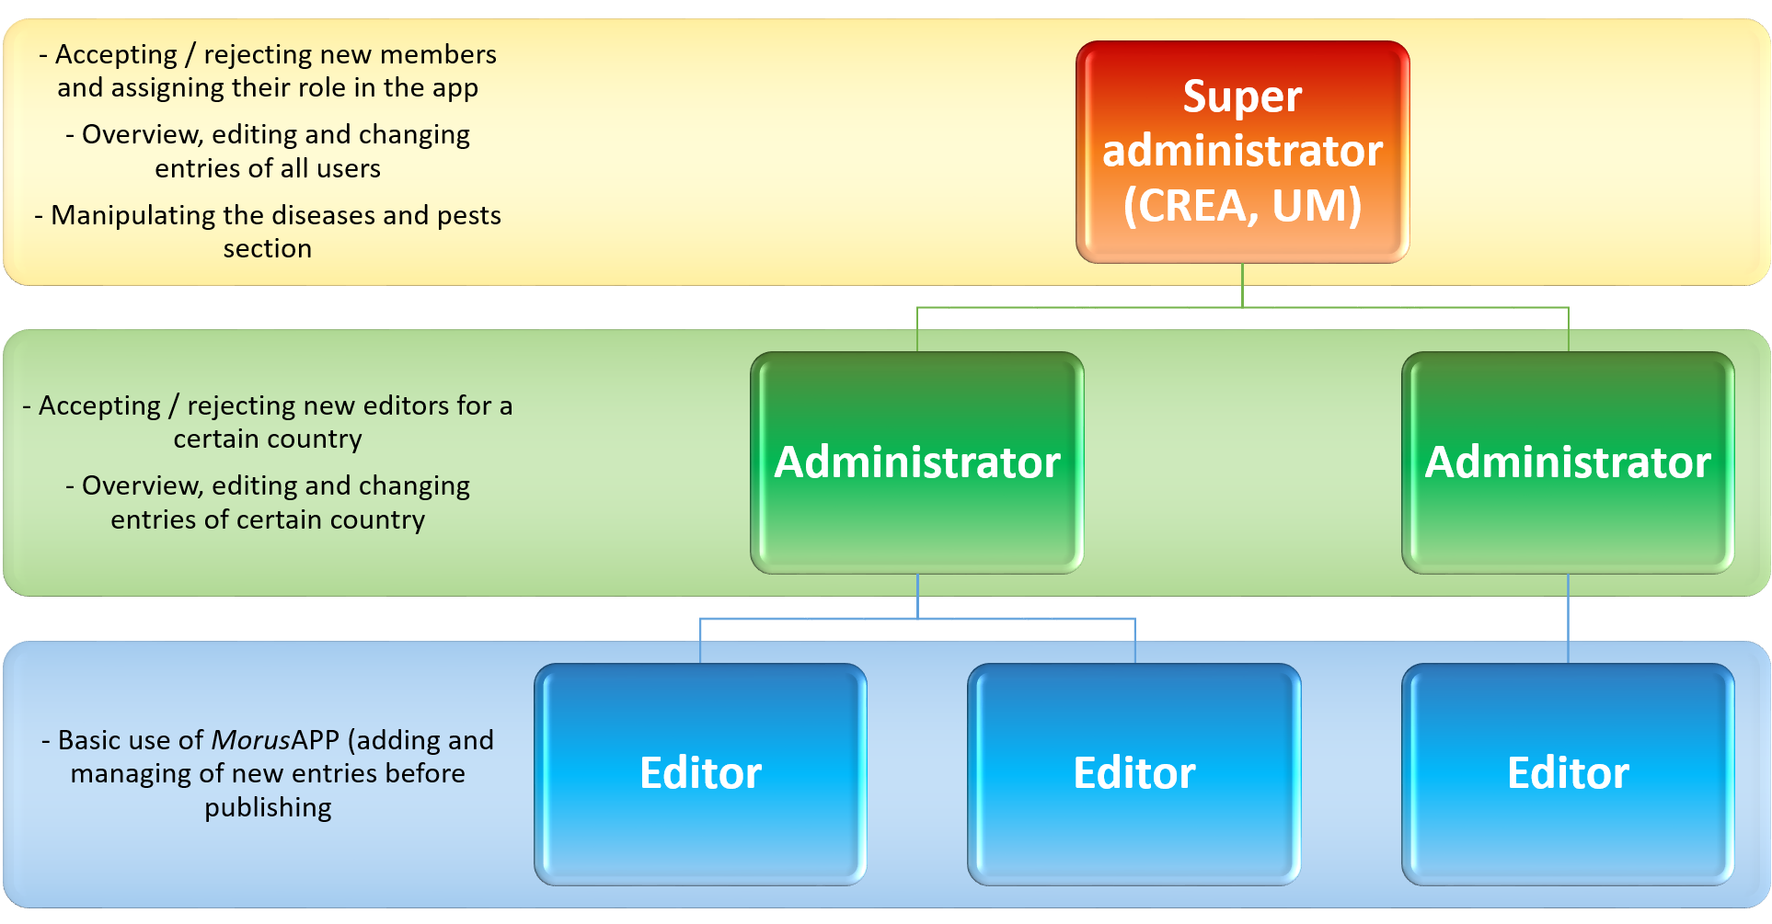
Figure 1: User’s roles and levels of published data access in the system.

We share Personal Information associated with Users’ registration and account (non-public location data from Observations You post, email address, etc.) with representatives (national administrators, general administrators) from ARACNE project partners. We also explicitly and publicly share this information in a machine-readable format with a handful of ARACNE project partners.
CREA is responsible for the secure storage and responsible use of the data, and develop their own criteria on how data may or may not be re-shared for non-commercial research, conservation, and mulberry species management purposes.
CREA in its sole discretion, may disclose non-public location data of threatened or sensitive species to researchers and affiliated organizations for research, conservation, and species management purposes.
CREA discloses Personal Information to contractors, service providers, consultants and affiliated organizations that (i) need to know that information in order to process it on Morus APP's behalf and (ii) that have agreed not to disclose it to others.
Morus App will not rent or sell Personal Information to anyone.
We use Microsoft Azure and we might use HGIS (to display geographic content and advanced GIS analyses by including bio-climatic data) as well as we use the provided descriptors for the statistical evaluation of recorded mulberry trees.
Other than as described above, Morus App discloses Personal Information only when required to do so by law. Unless authorized by You through written consent, We will make Your Personal Information available to non-affiliated third parties only in the following circumstances:
- If We are compelled to do so by a governmental agency, court, or other entity (e.g., to respond to subpoenas, court orders or legal process);
- If We believe Your actions violate a law, regulation, this Privacy Policy, or any applicable website or app's terms of use, or if You threaten the rights, property or safety of our App;
If You are a registered User of Morus App and have supplied Your email address, Morus App may occasionally send You an email to tell You about new features, solicit Your feedback, or just keep You up to date with what's going on with Morus App. We expect to keep this type of email to a minimum. Morus App takes all measures reasonably necessary to protect against the unauthorized access, use, alteration, or destruction of Personal Information. You can unsubscribe from email communications by changing your account settings, deleting your account, or contacting Us at Morus@um.si

Legal Basis for Processing Personal Information Under the General Data Protection Regulation (GDPR)
We process Personal Information with the principle of data minimization in mind. This means that We limit ourselves to the minimum amount of personal information which is needed to achieve the particular purpose for which We process the Personal Information. Below are some examples of the purposes for which Personal Information may be processed.
Morus App may process Your Personal Information because:
- The processing is necessary to provide the services and features for which the App was designed
- The processing is necessary to perform our research in the framework of the ARACNE project
The legal basis for processing personal information are the arts. 6 and 9 of GDPR (j): processing and filing personal data is necessary for public interest, scientific research, in a way proportional to the aims and adopting specific measures to protect data and fundamental rights of the interested subject.

How We Retain Personal Information
We retain Your Personal Information associated with Your registration for so long as You remain a registered User of Morus App. In addition, We may retain Personal Information from closed accounts to comply with national laws, prevent fraud, resolve disputes, troubleshoot problems, assist with any investigation, enforce Our User Agreement and take other actions permitted or required by applicable national laws.
Personal information associated with Observations (time, date, location, etc.) may remain attached to Observations, even after You have closed Your account unless You request that We delete it.

Children
We do not knowingly collect or solicit Personal Information from children. Visitors younger than 16 years must obtain an adult's permission before submitting any Personal Information to our Platform (art. 8 GDPR). In the event that We learn that We have received any Personal Information from a visitor less than 18 years of age, and We do not receive parental permission within a reasonable period of time of Our request for it, We will delete that information as quickly as possible. If You believe that We might have Personal Information from or about a child less than 18 years of age please contact Us at Morus App Data Protection Officer at valentina.longo@crea.gov.it

Cookies
Automated technology collects information from Your computer or mobile device using session cookies. Session cookies are cookies that last for a session. A session starts when you launch a website or web app and ends when you leave the website or close your browser window. Session cookies contain information that is stored in a temporary memory location which is deleted after the session ends. Unlike other cookies, session cookies are never stored on your device. Therefore, they are also known as transient cookies, non-persistent cookies, or temporary cookies.

As You access or use Our App, We may collect information using session cookies, web beacons, pixels, navigational and location data collection (clickstream, log files, server logs) and other similar technologies for the purposes described in this Policy. Morus App uses session cookies to help Mulberry App identify and track visitors, their usage of the same App. Morus App visitors who do not wish to have cookies placed on their computers should set their browsers to refuse cookies before using the App. Certain features of Morus Apps, such as the ability to post Observations, may not function properly without the aid of cookies.

How We Protect Your Personal Information
We are committed to protecting the Personal Information You share with Us through the use of Morus App and We maintain reasonable physical, electronic and procedural safeguards to protect Your Personal Information. We limit access to Personal Information by Our own employees to individuals who are authorized for the proper handling of such information and any employee found violating Our standards of security and confidentiality is subject to Our disciplinary processes. We request Our service providers to follow the same policy. Unfortunately, We cannot guarantee that data transmitted over the Internet will always be secure. As a result, although We strive to protect Your Personal Information, We cannot ensure or warrant the security of any information You transmit or We may learn as a result of Your use of Morus App and You do so at Your own risk. If, for any reason, You do not agree with this Privacy Policy, please do not use or attempt to take advantage of any of the information, services, features or functions of Morus App that might require You to provide Your Personal Information.
Your Rights with Your Personal Information
You have certain rights with regard to Your Personal Information. Those include:
- The right to access, update or delete the information We have about You. In many instances, You can personally access and update Your Personal Information by accessing Your online account settings when logged in by going to the UM server (art 15, 17 GDPR). If You are unable to perform these actions yourself, please contact Us to assist You.
- The right of rectification. You have the right to have Your information corrected if that information is inaccurate or incomplete (art. 16 GDPR)
- The right to object. You have the right to object to our processing of Your Personal Information. (art. 20 GDPR)
- The right of restriction. You have the right to request that We restrict the processing of Your Personal Information. (art. 17 GDPR)
- The right to data portability. You have the right to be provided with a copy of the information that We have about You in a structured, machine-readable and commonly used format. (art. 20 GDPR)
- The right to withdraw consent. In cases where consent constitutes the legal basis for the processing of personal data (art. 6, §.1, letter a) and in particular cases (art. 9, §.2, letter a) , You have the right to withdraw Your consent at any time where Morus App relied on Your consent to process Your personal information.
Please note that for Your safety and security, We may ask You to verify Your identity before responding to such requests. For any such information or requests, contact the Morus App Data Protection Officer at valentina.longo@crea.gov.it

Posting Observations
If You do not wish to have the time, date, place, or other identifying information of an Observation included on Morus App, You should not post an Observation. Upon Your request, We will close Your account .

Withdraw Consent
If You withdraw Your consent for the use or disclosure of Your Personal Information for purposes set out in this Privacy Policy You may not have access to the App and We might not be able to provide You all of the Services and support offered to Our users and authorized under this Privacy Notice and Our User Agreement.
The Data Controller
The Data Controller who collects and processes your Personal Information is: CREA at crea@crea.gov.it

Privacy Policy Changes
Although most changes are likely to be minor, Morus App may change its Privacy Policy from time to time, and at Morus App sole discretion. We will post an updated and revised version of this Privacy Policy on the Morus App Platform when any material changes have been made, and Morus App researchers encourages visitors to check this Privacy Policy often so You are aware of the most current terms and conditions that apply to You. The revisions are effective immediately upon posting. Your continued use of this site after any change in this Privacy Policy will constitute Your acceptance of such change.

All Users
If any User of Our Platform, has any questions about this Privacy Policy, please contact the CREA Data Protection Officer at valentina.longo@crea.gov.it

Information updates
The information is made available to the interested party, together with any updates, on the site at the address https://dsr.feri.um.si/about

